Create a Dashboard in IRIS

## Create a Cube linked to the Class with the Data you want to work with

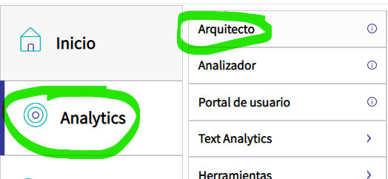

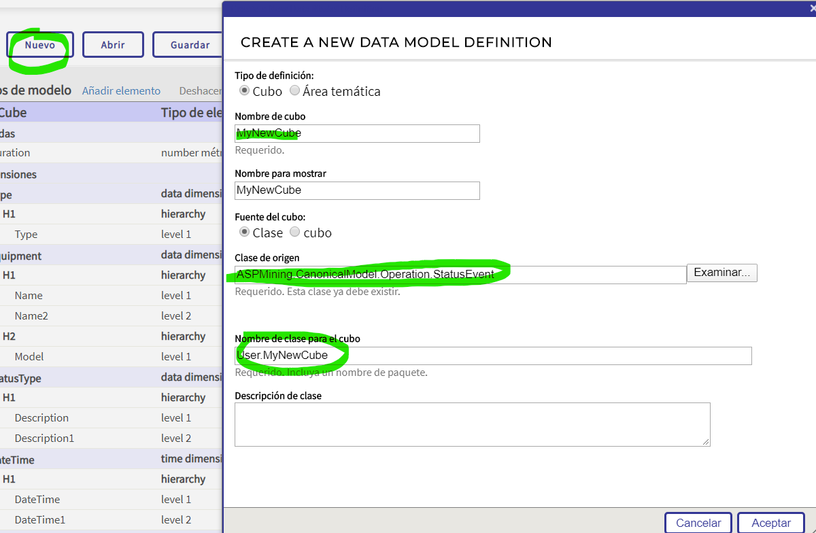

## Choose the Dimensions and Measures you want.

Hierarchy Levels are used to be able to Drill Down into the data

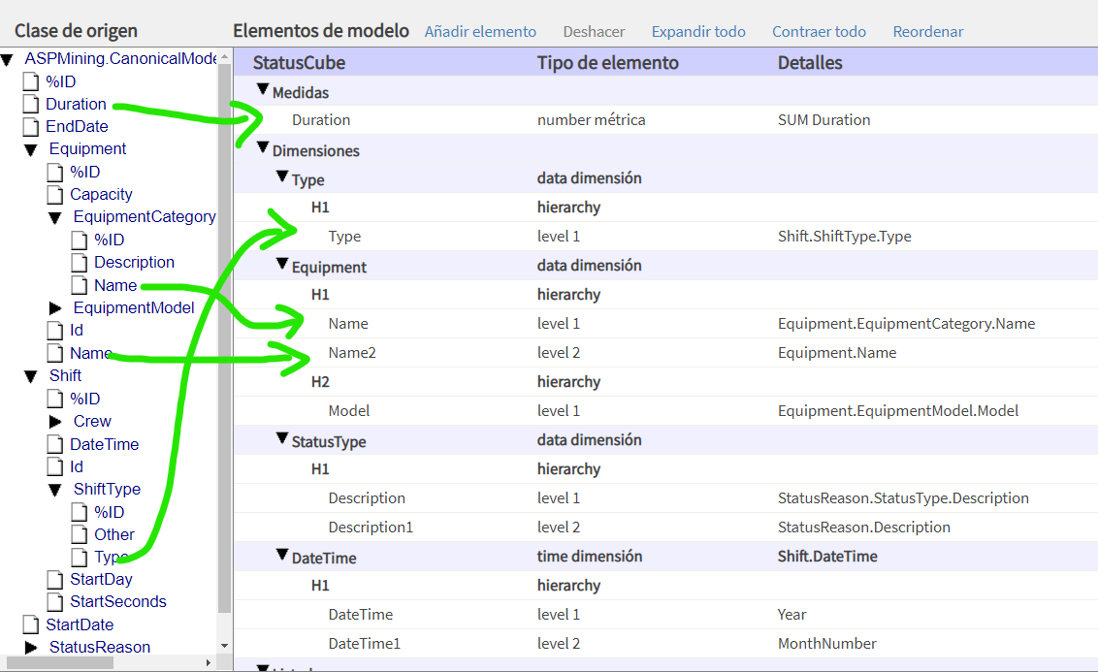

## Compile and Build your Cube

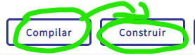

## Go to the Analyzer and Create a Dynamic Table for your Cube

This step will define what data will be used when creating a plot for your dashboard.

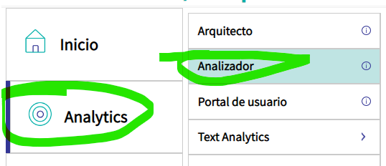

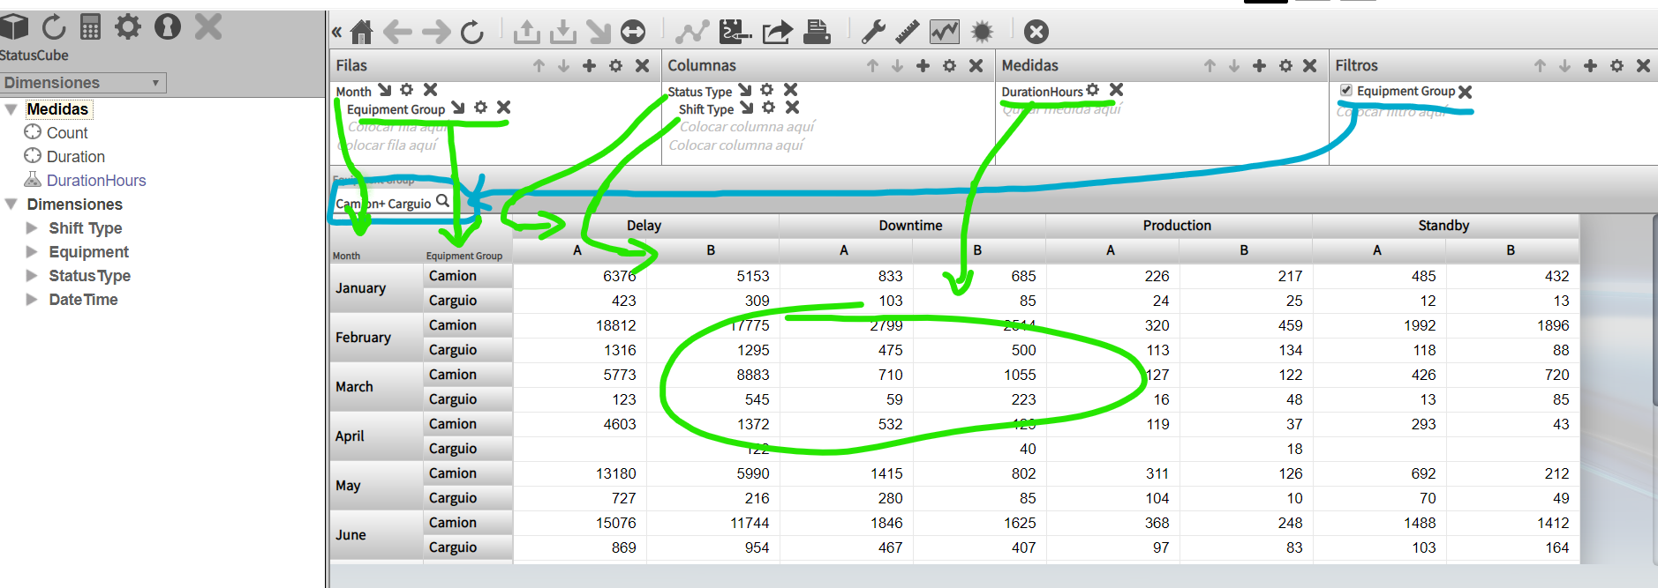

## Save Table and go to User Portal to Create a Dashboard

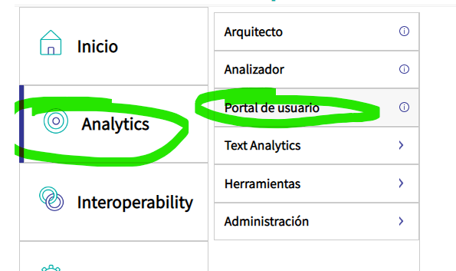

## Add a Dashboard

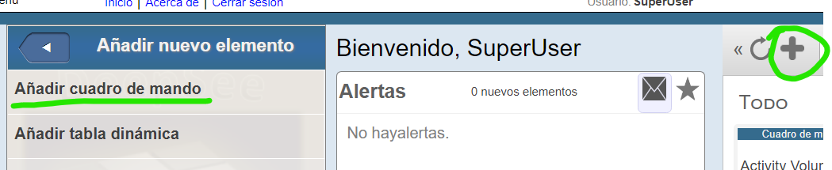

## Add a Widget and Link it to your Dynamic Table

